DEVELOPER GUIDE

|  |  |
| --- | --- |
|  | **Group Member:-**   * Syed Zohaib Hussain(Group Leader) * Muhammad Nabeel Tariq * Muntaha * Najeeb Ahmed * Syed Muhammad Danish Ali |

|  |  |  |
| --- | --- | --- |
| **S.No** | **Content** | **Pg. No** |
| **1** | **Acknowlegdment** | **2** |
| **2** | **Introduction Of App** | **3** |
| **3** | **Requirment Specification** | **3** |
| **4** | **Project Duration** | **4** |
| **5** | **Task Sheet** | **5** |
| **6** | **Snapshot** | **6** |

**CONTENT**

**ACKNOWLEGDMENT**

**W**

e are thankful to Almighty, ALLAH that by His grace we have been successful. we presenting on **Window Application** in your hands. We have tried our best to take all relevant important topics in consideration so that this project may become comprehensive.

This is our **Third Semester E-Project**. We have tried our best & struggled for a better outlook to come. This project has been developed in **VISUAL STUDIO 2013 .** We make Application for **Seven Wonders Guide** as a project.

We earnestly hope that this project will provide all the necessarily information required for the user to fulfill their inspiration. However suggestions for improvement of the project will be thankful received & acknowledge.

 Group leader

**INTRODUCTION OF THE APP**

**Seven Wonder** is informative Guide Application which gives information about various Wonders on the Earth, Due to rapid development in construction, the company decides to launch an Application where people will get all the information about the various Various Wonders easily.

**REQUIRMENT SPECIFICATION**

**SEVEN Wonders** mobiles app is informative mobile app with all information about monuments and places. It contains brief history and links to the web-sites.

App should have proper listing of SEVEN Wonders in alphabetical order.

**HARDWARE REQUIRMENT**

* A minimum computer system that will help you access all the tools in the
* courses is a Pentium 166 or better
* 128 Megabytes of RAM or better
* Windows 2000 Server (or higher if possible)

**SOFTWARE REQUIRMENT**

* Win-8/Visual Studio .net/C#/Notepad/SQL

**Project Duration**

* Analysis 1 Week.
* Design 3.5 Weeks.
* Development 2 Weeks
* Testing 1 Week
* Documentation 2 Days
* Content 1 Week

# Task Sheet

|  |  |  |  |
| --- | --- | --- | --- |
| **S.no** | **Task** | **Team Members** | **Status** |
| 1 | Analysis | Syed Zohaib Hussain | Done |
| 2 | Design | Syed Zohaib Hussain | Done |
| 3 | Content | Syed Muhammad Danish Ali, Najeeb Ahmed,  Muntaha, Nabeel Tariq | Done |
| 4 | Development | Syed Zohaib Hussain | Done |
| 5 | Testing | Syed Zohaib Hussain | Done |
| 6 | Documentation | Syed Zohaib Hussain | Done |

0

CITIES

WONDERS

Beirut

Durban

La Paz

Doha

Havana

Vigan

Kuala Lumpur

Great Barrier Reef

Deep-Sea Vents

Lake Baikal

Iguazu Falls

Hạ Long

Jeju Island

Table Mountain

Puerto Princesa Underground River

Amazon rainforest

Komodo

Machu   
Picchu

Christ the Redeemer

Great Wall of China

Petra

Colosseum

Taj Mahal

Chichen  
Itza

Belize Barrier Reef

Palau

Northern Red Sea

Galápagos Islands

Victoria  
Falls

Paricutlin  
Volcano

Mount  
Everest

Grand  
Canyon

Aurora

[Great Barrier  
Reef](https://en.wikipedia.org/wiki/Great_Barrier_Reef)

[Harbor](https://en.wikipedia.org/wiki/Guanabara_Bay) of [Rio de Janeiro](https://en.wikipedia.org/wiki/Rio_de_Janeiro)

UNDER WATER

WONDERS

NATURE

WONDERS

NATURAL

WONDERS

NEW

WONDERS

WONDERS

MAPS

Home

**SNAP SHOTS**

# 1)Loading Page:-

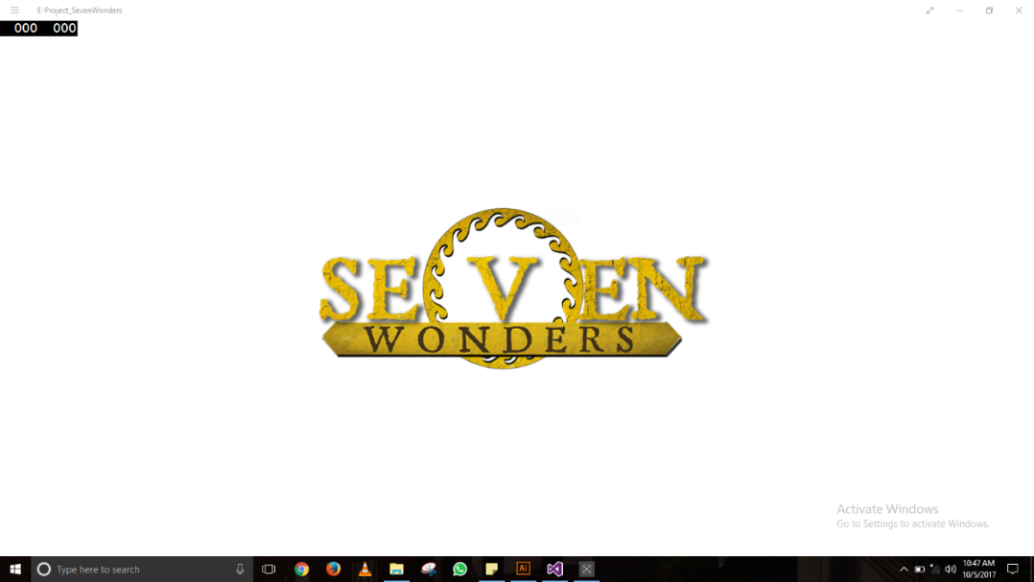

**2)Home Page**

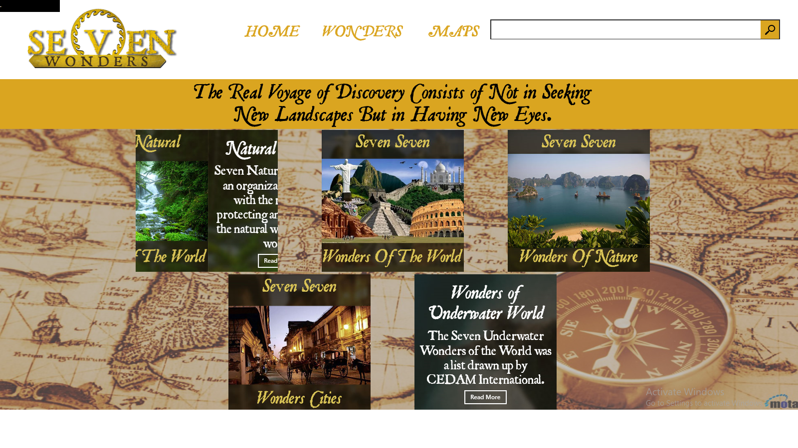

DispatcherTimer timer = new DispatcherTimer();

timer.Interval = TimeSpan.FromSeconds(7);

timer.Tick += timer_tick5;

timer.Start();

void timer_tick(object sender, object e)

{

int count = flipslide.Items.Count;

int indexCount = (flipslide.SelectedIndex + 1) % count;

flipslide.SelectedIndex = indexCount;

}

<FlipView Width="350" Height="350" x:Name="flipslide1" HorizontalAlignment="Left" Margin="0,0,0,0" SelectionChanged="flipslide_SelectionChanged"><FlipView.Items><FlipViewItem>

<Image Source="Assets/Banners/HomeBanner1.jpg" Stretch="Fill"></Image>

</FlipViewItem><FlipViewItem><StackPanel Orientation="Vertical"><StackPanel.Background><ImageBrush ImageSource="Assets/Banners/HomeBanner1-2.jpg" Stretch="Fill"/></StackPanel.Background>

<TextBlock TextAlignment="Center" Text="Natural Wonders" FontFamily="Assets/Font/JANCIENI.TTF#JSL Ancient" FontSize="50" TextWrapping="Wrap" HorizontalAlignment="Center" Margin="0,25,0,0"></TextBlock>

<TextBlock TextAlignment="Center" FontFamily="Assets/Font/JANCIENT.TTF#JSL Ancient" FontSize="35" TextWrapping="Wrap" Margin="10,10,10,0" Text="Seven Natural Wonders is an organization created with the mission of protecting and promoting the natural wonders of the world."></TextBlock><Button x:Name="NaturalRead" HorizontalAlignment="Center" Content="Read More" Click="NaturalRead_Click"></Button>

</StackPanel></FlipViewItem></FlipView.Items></FlipView>

